Advanced PLC Midterm  
Authors: Dan Blanchette and Brent Knopp  
Association: University of Idaho Coeur d’Alene

# Project Description

Develop and integrate a cooling and heating system with a digitally displayed thermostat for ambient room temperature and relative humidity. The PLC HMI displays the AC voltage usage from our heat source. We utilize a dual mechanical thermostat to orchestrate when our fan should run or when the heater should be turned on. The system is initialized by a push button start and stop with E-stop also included to lock the system out in the event of an emergency.

# Project Goals

* Integrate PLC and HMI
* Integration of start, stop, and E-stop buttons with the PLC.
* Integrate the Schnieder SMART thermostat to display register data for temperature and relative humidity via its HMI touch screen.
* Integrate a dual mechanical thermostat to trigger cooling and heating from a box fan and box heater.
* Read analog current from the heater with a transducer via a sensor and display real-time data on the PLC HMI.

# Hardware Used

* Schnieder TM172 07-18 PLC
* Schnieder TM172 07-18 PLC-HMI
* Schnieder TM172DLCWTHP Smart Thermostat
* Box Heater
* Box Fan
* 6-amp fuse, 3(½ amp fuses)
* 120V to 24v AC to DC converter
* 10-amp current transducer
* AC voltage sensor
* Start and Stop Button Assembly
* Emergency Stop Assembly
* 3 Relays

# Block Diagram

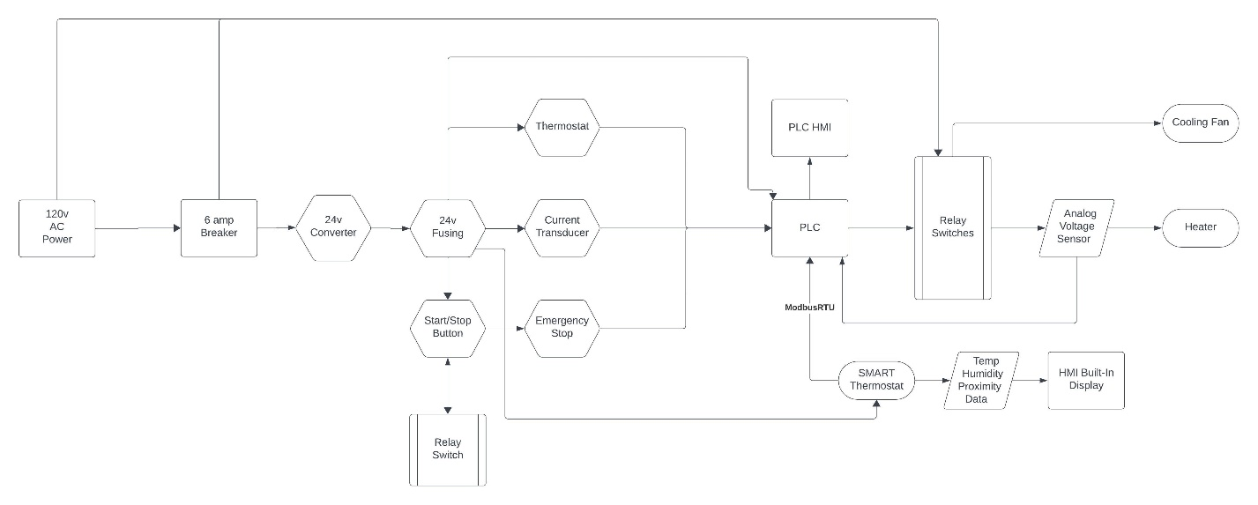

# Problems Encountered and Solved

1. Hardware issue 1
   1. Distinguishing a blind PLC from an expansion module.
   2. ModbusRTU integration was split between the device installer software and programming software which with more devices can become cumbersome to stay organized.
2. Software issue 1
   1. Schnieder proprietary software tool chain was not intuitive to use.
3. Documentation issue
   1. Manuals were identical across all products.
   2. Company while better docs were outdated and did represent present software.

# Future Work

Integrating SMART thermostat with the PLC to read register data and use it to control the cooling and heating system and removing the mechanical thermostat.